Department of Information Technology

Semester: V Name of Student:
Academic Year: 2022-23 Student ID:
Class / Branch: TE IT
Subject: Security Lab (SL)
Name of Instructor: Prof. Apeksha Mohite

EXPERIMENT NO. 3B

Aim: To study analysis of network packets by sing open source sniffing tools like tcpdump and Wireshark in promiscuous and non-promiscuous mode.

• tcpdump -D : display all available interfaces
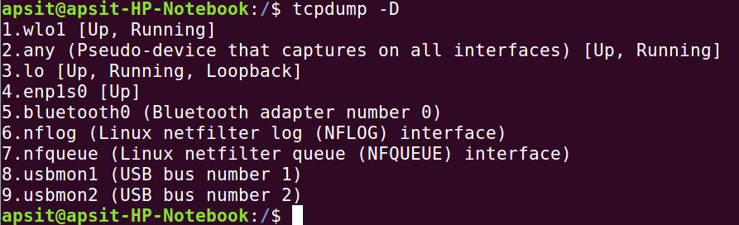

• tcpdump -i wlo1 : capture traffic at the interface “wlo1”
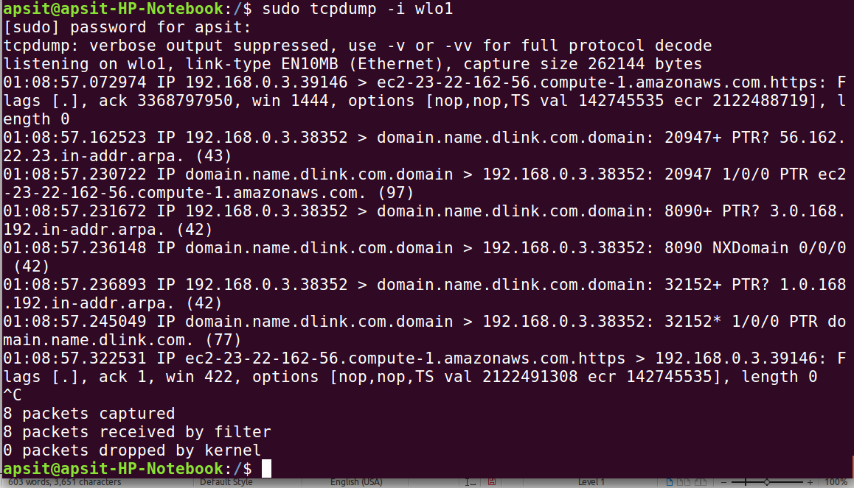

• tcpdump -i wlo1 port 80 : capture traffic at the interface “wlo1” on port 80
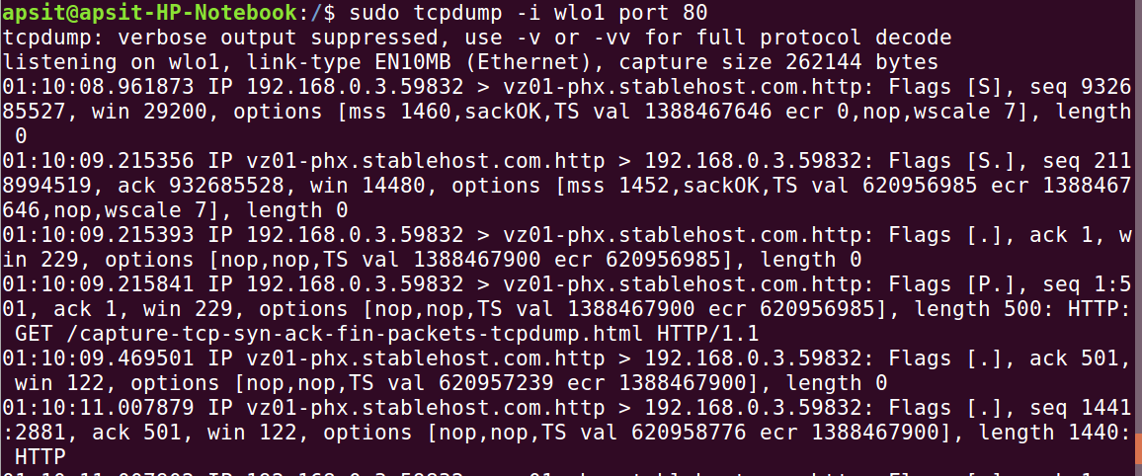

• tcpdump -i wlo1 -c 5 : capture 5 packets at the interface “wlo1”
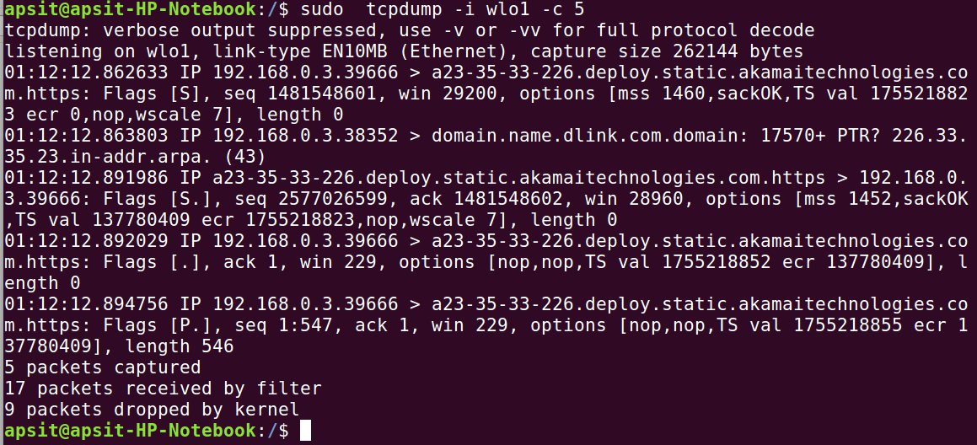

• tcpdump -i wlo1 tcp : capture only tcp traffic at interface “wlo1”
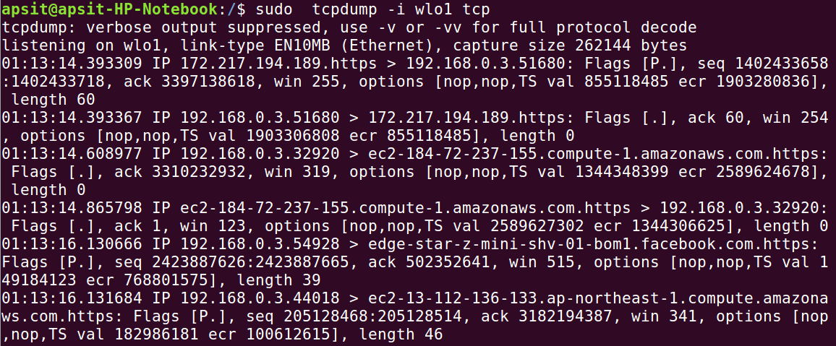
To capture only TCP ACK packets:
sudo tcpdump -i wlo1 "tcp[tcpflags] & (tcp-ack) != 0" >/home/apsit/Desktop/ack.txt
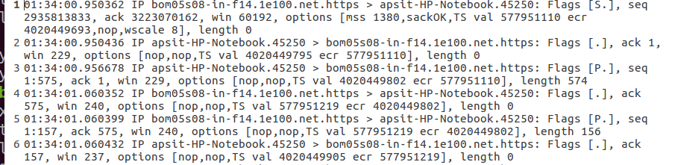
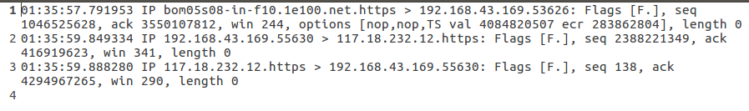
To capture only TCP FIN packets:
To capture ssh packet:sudo tcpdump -i wlo1 -x -X -A -nvvv port 22 > ssh.txt
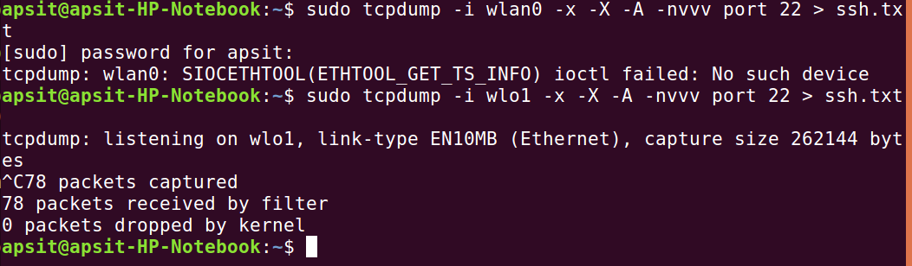
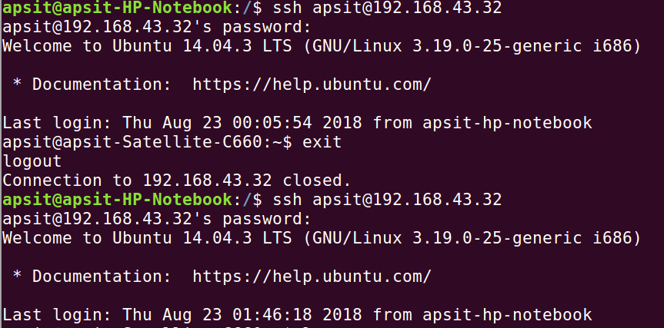
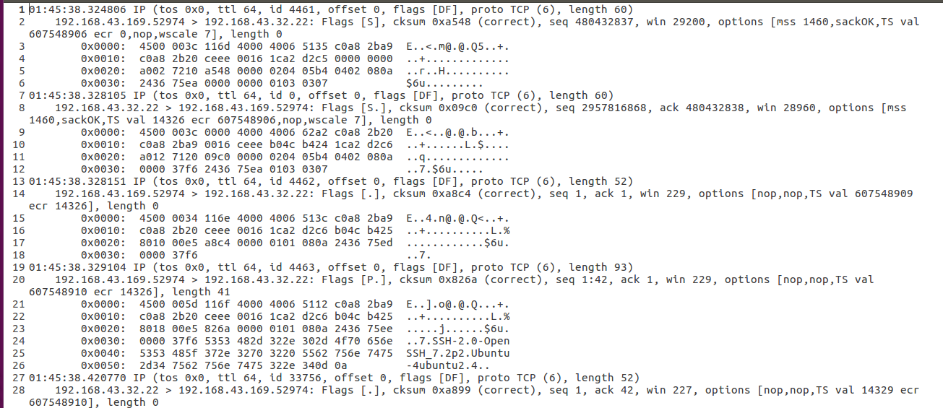
Wireshark:
Capture Data Packets in Wireshark:

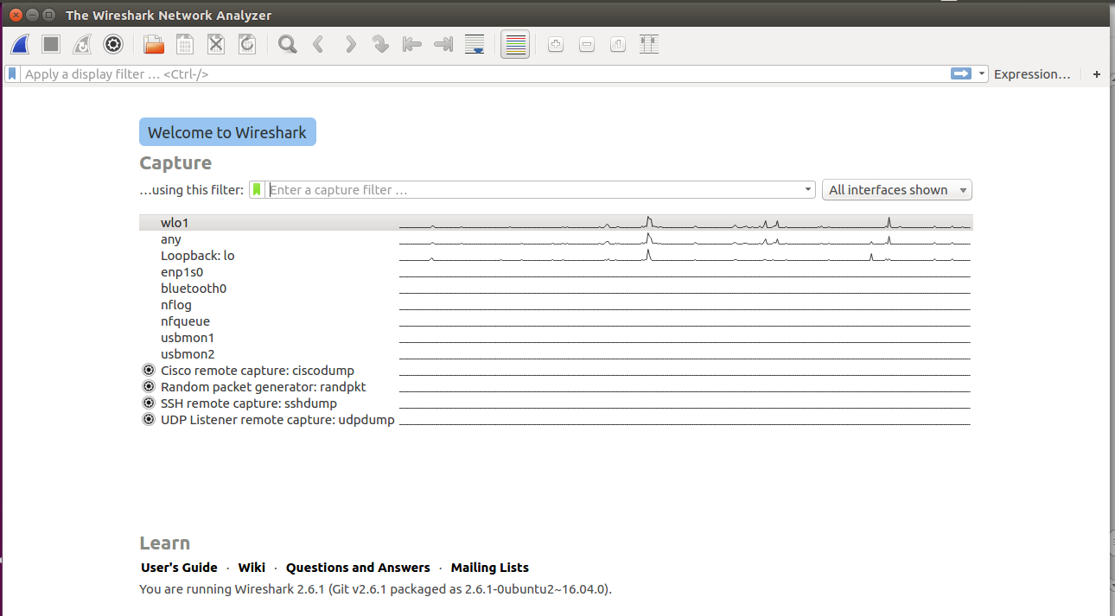

To begin capturing, select the interface and click on Capture button at the top.
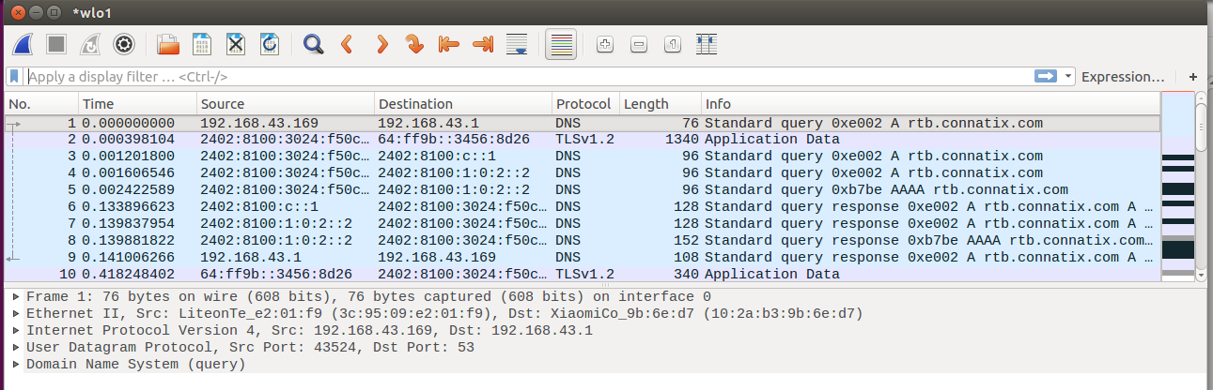
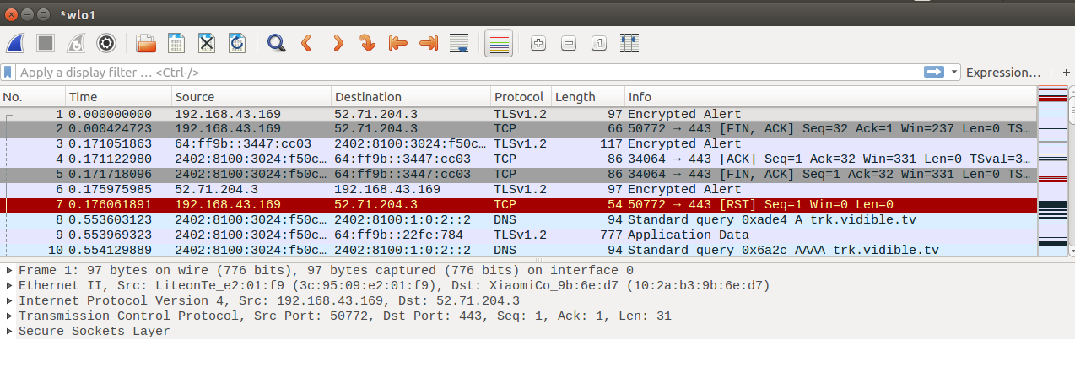
1. Start capturing packets in Wireshark. While in process initiate a telnet connection.
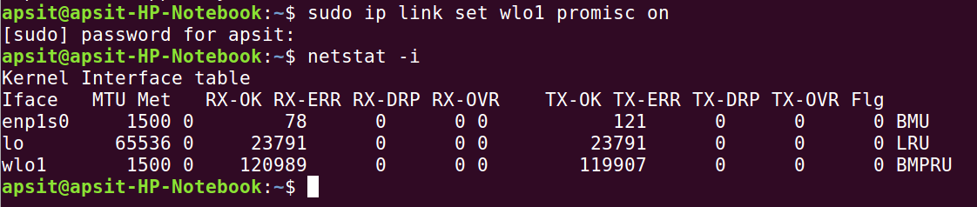
Promiscuous and non promiscuous mode:

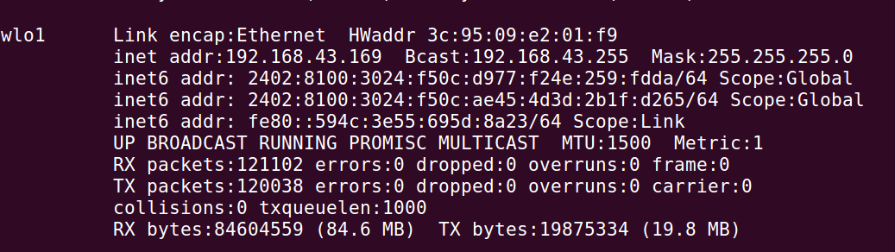
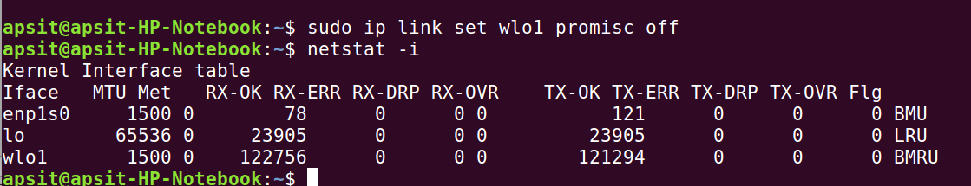

Promiscous mode enable/disable in wireshark:
